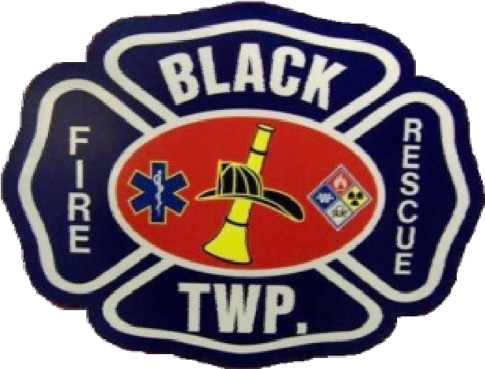

BLACK TOWNSHIP FIRE & RESCUE
County Rope Rescue Team
5775 Industrial Road; Mount Vernon, IN 47620
Phone: (812) 838-4355 www.blacktwpfire.org
Serving the public since 1952

APPLICATION FOR MEMBERSHIP COVER SHEET

NAME OF APPLICANT: _______________________________________________________

FIRE DEPARTMENT REVIEW
(The following will be reviewed by the BTFR Special Operations Division Chief and Fire Chief)

COPY OF VALID INDIANA DRIVERS LICENCE
PROVIDED BY APPLICANT: YES / NO

DATE APPLICATION RECEIVED: ________________________
(Date)

REVIEWED BY FIRE CHIEF: ____________________________________ __________________ (Fire Chief Signature) (Date)

DATE APPLICATION APPROVED / DENIED: ____________________
(Date)

APPLICATION FOR MEMBERSHIP

GENERAL INFORMATION:
Name of Applicant:
(Last) (Middle) (First)

Current Address:
Street Address

City State Zip Code

Email Address: Phone No.:
Drivers License No.: Alt Phone No.:

Emergency Contact
Name of Emerg. Contact:
(Last) (Middle) (First)

Current Address:
Street Address

City State Zip Code

Phone No.: Alt Phone No.:

Department Affiliation:

Dept. Fire Chief:
(Last) (First)
Dept. Fire Chief Phone No.:

The Department Fire Chief of the applicant authorizes that the applicant can be a part of the County Rope Team.

Fire Chief Signature:

Indiana Fire & EMS Certifications Only: (Please check all that apply)
First Responder or EMR Exp Date:____________ EMT-B Exp Date: _____________
Rope Rescue Awareness Rope Rescue Operations/Technician
NIMS Certifications: 100 200 300 400 700 800
PSID:
CPR and/or First Aid Certification(s):
Provider: American Heart Association American Red Cross
Certificate Level: Basic CPR Basic CPR & First Aid Professional Rescuer
Exp Date:
Other Fire & EMS Certifications:

ACKNOWLEDGEMENT
I certify the information given in this application and all supplemental sheets is true and complete to the best of my knowledge. I understand that misrepresentation or omission of fact on this application and/or any supplemental sheet may constitute grounds for disqualification or termination from the Count Rope Team regardless of when the misrepresentation or omission is discovered.

Black Township Fire & Rescue provides equal employment opportunities (EEO) to all members and applicants for membership without regard to race, color, religion, gender, sexual orientation, gender identity, national origin, age, disability, genetic information, marital status, amnesty or status as a covered veteran in accordance with applicable federal, state and local laws. Black Township Fire & Rescue complies with applicable state and local laws governing nondiscrimination in employment in every location in which the company has facilities. This policy applies to all terms and conditions of employment, including, placement, promotion, termination, transfer, leaves of absence, and training.

Black Township Fire & Rescue expressly prohibits any form of unlawful employee harassment based on race, color, religion, gender, sexual orientation, national origin, age, genetic information, disability or veteran status. Improper interference with the ability of Black Township Fire & Rescue employees to perform their expected job duties is absolutely not tolerated.

I authorize any person, agency, partnership or corporation having any information concerning my background and qualifications to release such information.

I agree to abide by all Standard Operating Guidelines, Bylaws and Rules and Regulations set forth by Black Township Fire & Rescue.

I have read these authorizations, agreements and release of all claims, and I expressly agree to the terms set out herein.

Applicants Signature Date

